App Analysis – Tapporo

# Introduction

This file contains an analysis of Tapporo in how it works and the various pros and cons for automating the process.

# Quick Glance

At a quick glance the following statistics apply to this app.

1. 1 Video = 5 Coins
2. 1 Coin = $0.001
3. Average Time Per Ad = 0 seconds (there doesn’t seem to be ads)
4. Average Video Play Time = 5 seconds (after fast forwarding video)
5. Maximum Coins Per Account Per Day = Unknown
6. Maximum Money Per Account Per Day = Unknown
7. Maximum Videos Per Account Per Day = Unknown
8. Maximum Amount Of Time To Reach Maximum Limit = Unknown
9. Maximum Devices Per Account = Unknown
10. Maximum Accounts Per IP = Unknown
11. Minimum Amazon Cash Out = $5.00
12. Minimum Cash Out = $5.00
13. Redemption Process Require Phone Number = Unknown
14. Redemption Process Require Facebook Account = Unknown

# How It Works

After downloading, installing, and opening up this app, the following screen is presented. This is only shown the first time the user opens the app. After the user logs in, this is no longer presented to them.

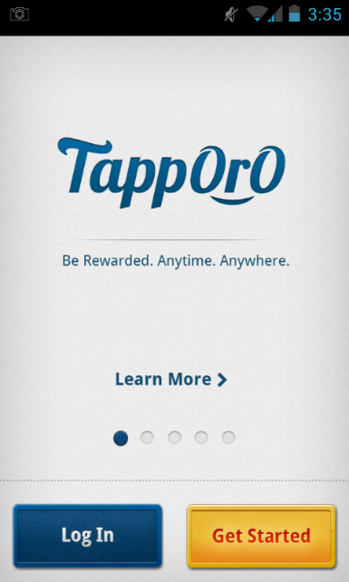

From there the user will either click Log In or Get Started. If the user clicks the Log In screen the following is presented to them.

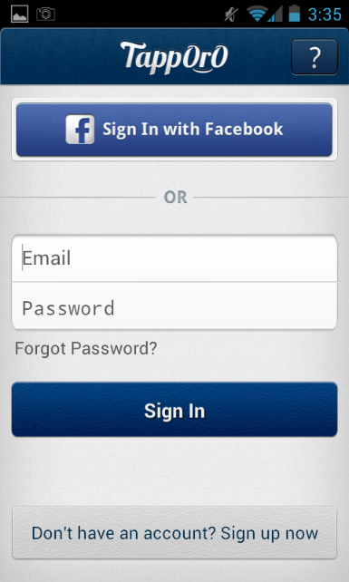

After creating an account or logging in, the user is taken to the following screen.

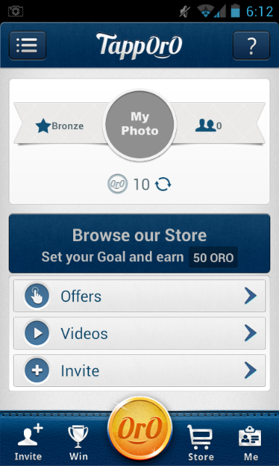

The user can then click on Videos to start watching videos. The user can also press the 3 dashes in the upper left hand corner which will open up the following window.

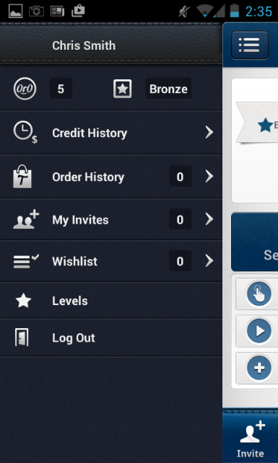

The above window has no real functionality.

When clicking on the Videos option on the home screen, the user will be shown the following.

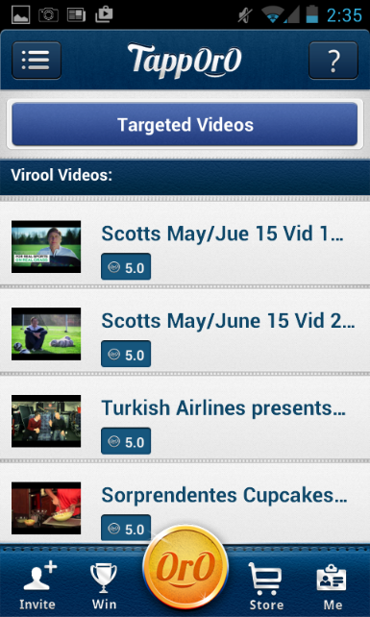

The user can then click on a video to be played. Notice that a web page is shown with a video to be played within the web page. After the video has been played, the user is granted the points. To see that the points were given to the user, you must look at the history of the user’s activity (which can be seen in the menu with the 3 dashes).



When the user presses the shopping cart icon that has the words “Cart” underneath it, the following is displayed to the user.

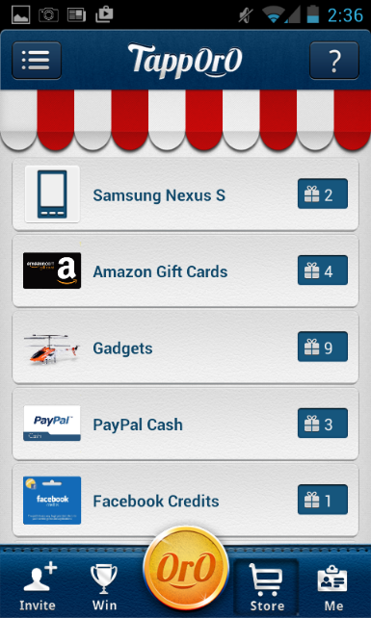

From here the user can click on the Amazon Gift Cards item and the following is shown.

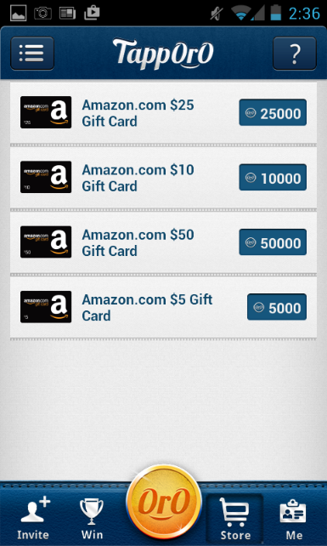

The user could then move forward with redeeming a gift card from this screen.

From the home screen if you click on Offers, the following will be shown.

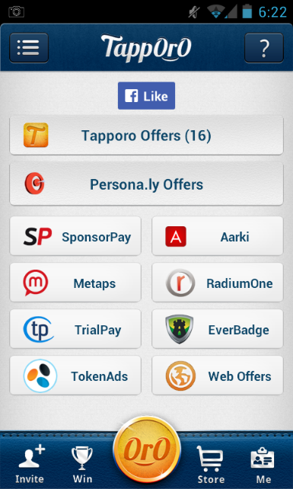

From there you can click on many third party vendors which have the same common theme. There is some action that should be performed in the third party space such as surveys, download apps, playing apps, and watching videos. When watching videos, they all open a web browser and you have to play the video in the web browser within the mobile device.

For example, if you click on TokenAds, the following will be shown to the user.

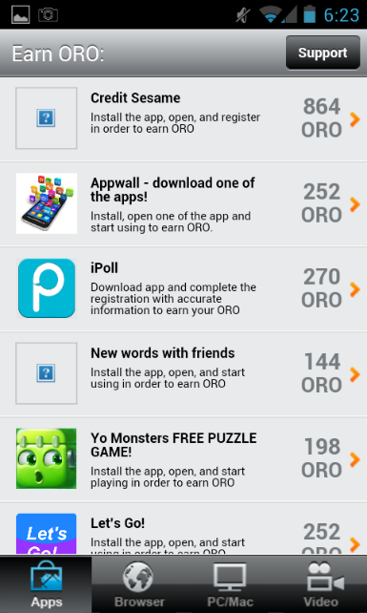

From there the user can click on the Video tab in the lower left hand corner. The following will be shown to the user.

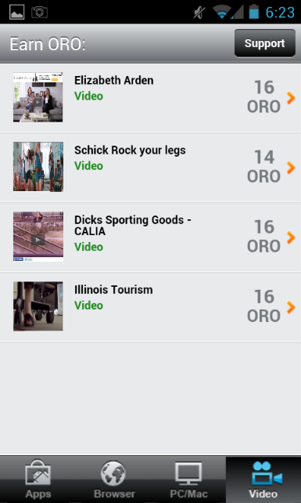

From here the user can select a video to be played. The following is then shown to the user.



The user can then play the video and attempt to fast forward the video to the end. In doing so, the video within the web browser may sometimes get stuck and actually restart the video from the beginning.

# Automation Pros

1. At first glance there doesn’t seem to be any limits.
2. There doesn’t seem to be ads that get played before the videos which would help speed up the amount of time playing each video.
3. The videos themselves can be fast forwarded, which in means that every 3-5 seconds (depending on load time) a new video can be playing. So if other apps make $0.01 per video and it takes 45 seconds to play the video, this app would worse case around 45 seconds / 5 seconds per video = 9 videos. 9 videos * $0.001 = $0.009 which is very close to $0.01.

# Automation Cons

1. The videos are being played within a web browser which is harder to automate then a video player located within the app.
2. The payout per video is extremely minimal at $0.001 per video.

# Unknowns

1. The redemption process is unknown, so we are not sure how complicated this process will be.